Code Review Checklist
Review Information:
Name of Reviewrer: 徐元璐
Name of Coder: 王喆
File(s) under review:
(1) 所属包:hibernate.dao
文件名:DoctorDAO.java,PatientDAO.java

Brief description of change being reviewed: 该版本为v_0.5.3版，已进一步完善了基本业务逻辑功能。对底层数据库的操作进行了纠错。
Review Notes:
本次review主要对DoctorDAO和PatientDAO类进行系统测试和纠错。

对DoctorDAO类进行测试，测试代码如下：
public class DoctorDAOTest extends TestCase {
public void testDoctorSave() {
DoctorDAO dao = new DoctorDAO();
Doctor doctor = new Doctor();
doctor.setPhysicianLicenseNum("aaaaaaaa");
doctor.setPassword("111111");
dao.save(doctor);

doctor.setPhysicianLicenseNum("bbbbbbbb");
doctor.setPassword("222222");
dao.save(doctor);

doctor.setPhysicianLicenseNum("cccccccc");
doctor.setPassword("333333");
dao.save(doctor);
}

public void testNoMatchQuery() {
DoctorDAO dao = new DoctorDAO();
Doctor doctor = dao.findById("abcdefg");
assertEquals( true, doctor == null);

List<Doctor> doctorlist = new ArrayList<Doctor>();
Doctor example = new Doctor();
example.setPhysicianLicenseNum("cccccccc");
example.setPassword("222222");
doctorlist = dao.findByExample(example);

assertEquals( true, doctorlist.size() == 0 );

doctorlist = dao.findByProperty("physicianLicenseNum", "abcdefg");
assertEquals( true, doctorlist.size() == 0 );

doctorlist = dao.findByProperty("password", "555555");
assertEquals( true, doctorlist.size() == 0 );
}

public void testMatchQuery() {
DoctorDAO dao = new DoctorDAO();
Doctor doctor = dao.findById("bbbbbbbb");
assertEquals( false, doctor == null );

List<Doctor> doctorlist = new ArrayList<Doctor>();
Doctor example = new Doctor();
example.setPhysicianLicenseNum("cccccccc");
example.setPassword("333333");
doctorlist = dao.findByExample(example);
assertEquals( false, doctorlist.size() == 0 );

doctorlist = dao.findByProperty("physicianLicenseNum", "aaaaaaaa");
assertEquals( false, doctorlist.size() == 0 );

doctorlist = dao.findByProperty("password", "111111");
assertEquals( false, doctorlist.size() == 0 );
}

public void testDoctorDelete() {
DoctorDAO dao = new DoctorDAO();
Doctor doctor = dao.findById("cccccccc");
dao.delete(doctor);
doctor = dao.findById("cccccccc");
assertEquals( true, doctor == null);

doctor = new Doctor();
doctor.setPhysicianLicenseNum("aaaaaaaa");
doctor.setPassword("111111");
dao.delete( doctor );
}

}
发现的问题：在运行DoctorDAO 类中的findByExample方法时，该方法没有判断了example的physicianLicenseNum变量，只是判断了password变量，这样导致了数据库中只要存在用户输入的密码就可以登录，即使数据库中并没有该用户的账号。
问题截图：
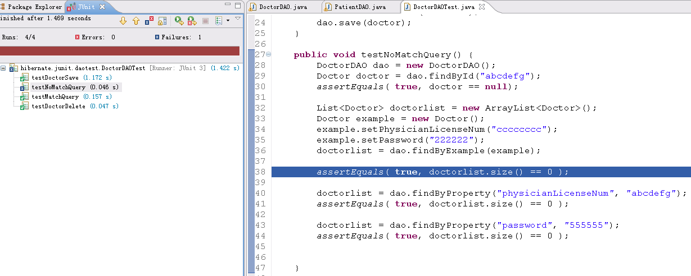

出现问题的代码段如下：
public List<Doctor> findByExample(Doctor instance) {
log.debug("finding Doctor instance by example");
try {
List results = getSession().createCriteria("hibernate.vo.user.Doctor")
.add( Example.create(instance)).list();
log.debug("find by example successful, result size: " + results.size());
return results;
} catch (RuntimeException re) {
log.error("find by example failed", re);
throw re;
}
}

在测试PatientDAO类时发现了同样的问题。
问题截图：
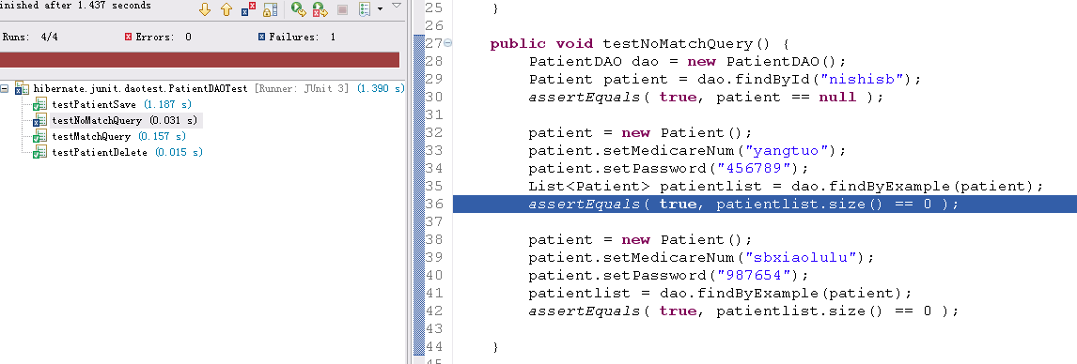
出现问题的代码段如下：
public List<Patient> findByExample(Patient instance) {
log.debug("finding Patient instance by example");
try {
List results = getSession().createCriteria("hibernate.vo.user.Patient")
.add(Example.create(instance)).list();
log.debug("find by example successful, result size: " + results.size());
return results;
} catch (RuntimeException re) {
log.error("find by example failed", re);
throw re;
}
具体是Example.create(instance)出现了问题，

17.6. Example queries
The class org.hibernate.criterion.Example allows you to construct a query criterion from a given instance.
Cat cat = new Cat();
cat.setSex('F');
cat.setColor(Color.BLACK);
List results = session.createCriteria(Cat.class)
.add( Example.create(cat) )
.list();
Version properties, identifiers and associations are ignored. By default, null valued properties are excluded.
You can adjust how the Example is applied.
Example example = Example.create(cat)
.excludeZeroes() //exclude zero valued properties
.excludeProperty("color") //exclude the property named "color"
.ignoreCase() //perform case insensitive string comparisons
.enableLike(); //use like for string comparisons
List results = session.createCriteria(Cat.class)
.add(example)
.list();
You can even use examples to place criteria upon associated objects.
List results = session.createCriteria(Cat.class)
.add( Example.create(cat) )
.createCriteria("mate")
.add( Example.create( cat.getMate() ) )
.list();

Review Reply:
出现上述问题的原因在于我对于Hibernate中Example作为查询条件的理解存在不足而导致的，首先我先查阅Hibernate3.2的文档，关于Example文档描述如下
这里文档中提到了一个关键的我忽略了的地方。
Version properties, identifiers and associations are ignored. By default, null valued properties are excluded.
也就是说，当使用Example作为模糊查询的时候， 会忽略这个实例中的主键映射， 集合映射和空值属性。而我们原来的代码中将账号（医师资格证号和医保卡号）分别作为各自表中的主键，在使用Example查询中实质上被忽略了，这样产生了一个非常严重的bug，只要用户在登录时输入了一个数据库中存在的密码，那么任何的用户名都会被认为是合法的。

针对以上两个问题我分别做了如下修改：
DoctorDAO类
public List<Doctor> findByExample(Doctor instance) {
log.debug("finding Doctor instance by example");
try {
List results = getSession().createCriteria("hibernate.vo.user.Doctor")
.add( Expression.eq("physicianLicenseNum",
instance.getPhysicianLicenseNum()))
.add( Expression.eq("password", instance.getPassword()))
.list();
log.debug("find by example successful, result size: " + results.size());
return results;
} catch (RuntimeException re) {
log.error("find by example failed", re);
throw re;
}
}

PatientDAO类
public List<Patient> findByExample(Patient instance) {
log.debug("finding Patient instance by example");
try {
List results = getSession().createCriteria("hibernate.vo.user.Patient")
.add( Expression.eq("medicareNum",
instance.getMedicareNum()))
.add( Expression.eq("password",instance.getPassword()))
.list();
log.debug("find by example successful, result size: " + results.size());
return results;
} catch (RuntimeException re) {
log.error("find by example failed", re);
throw re;
}

上述代码不易理解，简单进行重构 DoctorDAO类
public List<Doctor> findByExample(Doctor instance) {
log.debug("finding Doctor instance by example");
try {
List results = getLikeResultsByExample(instance);
log.debug("find by example successful, result size: " + results.size());
return results;
} catch (RuntimeException re) {
log.error("find by example failed", re);
throw re;
}
}

private List getLikeResultsByExample(Doctor example) {
return getSession().createCriteria("hibernate.vo.user.Doctor")
.add( Expression.eq("physicianLicenseNum",
example.getPhysicianLicenseNum()))
.add( Expression.eq("password", example.getPassword()))
.list();
}

PatientDAO类
public List<Patient> findByExample(Patient instance) {
log.debug("finding Patient instance by example");
try {
List results = getLikeResultsByExample(instance);
log.debug("find by example successful, result size: " + results.size());
return results;
} catch (RuntimeException re) {
log.error("find by example failed", re);
throw re;
}
}

private List getLikeResultsByExample(Patient instance) {
return getSession().createCriteria("hibernate.vo.user.Patient")
.add( Expression.eq("medicareNum", instance.getMedicareNum()))
.add( Expression.eq("password", instance.getPassword()))
.list();
}

这里我修改了原来的使用的Example结构进行查询的代码，改成完整的条件查询。重新运行junit test, 运行测试通过，截图如下。
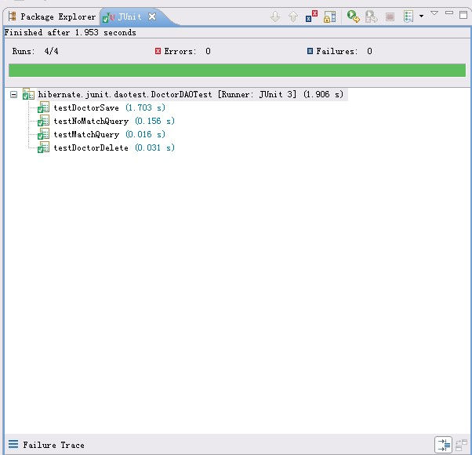

Review Result:
程序出现的bug被完美解决，工程前进到V0.5.4

